

SPECIFICATION SHEET

DRAPERY HARDWARE

- GENERAL
  - SECTION INCLUDES
    - Drapery Track and hardware.
    - Motorized drapery track devices.
  - RELATED SECTIONS
    - Section 05500 - Metal Fabrications: Above ceiling track metal support and anchors.
    - Section 06114 - Wood Blocking and Curbing: Above ceiling track wood support and anchors.
    - Section 06220 - Wood Trim: Window frame trim and support for track anchors.
    - Section 09900 - Paints and Coatings: Field Painting.
    - Section 12497 - Curtains and Drapes: Draperies.
    - Section 16150 - Wiring Connections: Wiring from control station to operator.
  - DESIGN / PERFORMANCE REQUIREMENTS
    - Electrical Components, Devices, and Accessories: Listed and labeled as defined in NFPA 70, Article 100, by a testing agency acceptable to authorities having jurisdiction, and marked for intended use.
    - Corded Window Covering Product Standard: Provide drapery tracks operated by pull cords complying with ANSI A100.1.
  - SUBMITTALS
    - Submit under provisions of Section 01300.
    - Product Data: Manufacturer's data sheets on each product to be used, including:
      - Preparation instructions and recommendations.
      - Storage and handling requirements and recommendations.
      - Installation methods.
      - Include maximum weights of draperies that can be supported.
      - Motorized Tracks: Indicate motor weights, motor-mounting requirements, and electrical requirements.
    - Shop Drawings: For track installation; reflected ceiling plans drawn to scale and coordinating track installation with openings and ceiling-mounted items. Indicate end track location, width of window opening, location of blocking for anchors, appurtenances and interferences, adjacent construction, operating hardware, and support bracket details.
    - Verification Samples: For each finish product specified, two samples, minimum size 6 inches (150 mm) square, representing actual product and color.
    - Manufacturer's Certificates: Certify products meet or exceed specified requirements.
    - Manufacturers warranties.
  - QUALITY ASSURANCE
    - Manufacturer Qualifications: Company specializing in manufacturing products specified in this section with minimum five years documented experience.
    - Installer Qualifications:
    - Mock-Up: Provide a mock-up for to verify selections made and installation workmanship.
      - Install mockup for each type of product and combination of products indicated.
      - Locate in areas designated by Architect.
      - Do not proceed with remaining work until workmanship and operating configuration is approved by Architect.
      - Refinish mock-up area as required to produce acceptable work. Incorporate accepted mockup as part of Work. Remove mockup [when directed by Architect/Engineer.] [________.]
  - DELIVERY, STORAGE, AND HANDLING
    - Store products in manufacturer's unopened packaging until ready for installation.
    - Protect materials from exposure to moisture. Do not deliver until after wet work is complete and dry.
    - Store materials in a dry, warm, ventilated weathertight location.
    - Store and dispose of solvent-based materials, and materials used with solvent-based materials, in accordance with requirements of local authorities having jurisdiction.
  - FIELD MEASUREMENTS
    - Verify field measurements are as indicated on shop drawings.
  - WARRANTY
    - Limited lifetime warranty, please refer to the Forest Group general warranty terms for additional information.
  - COORDINATION
    - Coordinate Work with other operations and installation of adjacent finish materials to avoid damage to installed hardware.
    - Coordinate Work of above ceiling including blocking, anchors and other support positioning.
    - Coordinate with related electric service and outlets.
  - EXTRA MATERIALS
    - Track Carriers: For each size indicated, equal to 5 percent of amount installed, but no fewer than 10 of each size.
    - Track Controls: For each type indicated, equal to 5 percent of amount installed, but no fewer than 10 of each type.
- PRODUCTS
  - MANUFACTURERS
    - Acceptable Manufacturer: Forest Group Nederland B.V., which is located at: Arnsbergstraat 4, 7418 EZ, Deventer, The Netherlands. Telephone: 0031 570 622 850; Fax: 0031 570 625 284; E-mail: info@forestgroup.nl; Website: www.forestgroup.nl.
    - Substitutions: Not permitted.
    - Requests for substitutions will be considered in accordance with provisions of Section 01600.
  - MANUALLY OPERATED TRACK AND ACCESSORIES
2.2 A KS Series
2.2 B CKS Series
2.2 C DS Series
2.2 D CS Series
2.2 E CS Lip / CM Ceiling Mount Series
2.2 F CCS Series
2.2 G MTS Series
2.2 H BS Series
2.3 MOTOR OPERATED TRACK AND ACCESSORIES
2.3 A FMS Series
2.3 B Shuttle Series
2.3 C BCS Series
2.4 INSTALLATION AND HANGING ACCESSORIES
2.4 A Universal Brackets
2.4 B FES Forest Easyfold System

    - KS System Series: Highly efficient hand drawn system used for light to medium draperies for residential and cubicle applications. Powder coated finish with track and carriers permanently lubricated for smooth operation.

      - Application: Hand drawn as follows:
        - Center close two way draw.
        - Off-center opening; two way draw.
        - One way draw left-to-right.
        - One way draw right-to-left.
        - Application as indicated on the Drawings.
        - Application as indicated on the Drapery Schedule.
      - Mounting: Suitable for fastening track to surface indicated and designed to support weight of track assemblies and drapery plus force applied to operate track. Provide steel brackets and intermediate supports every 60 to 90 cm, depending on weight of drape as required.
        - Number of Tracks:
          - Single.
          - Double.
          - Triple.
          - As indicated on the Drawings.
          - As indicated on the Drapery Schedule.
        - Wall with a ___ inch projection.
        - Ceiling.
        - Recessed.
        - Direct with channel protectors.
        - As indicated on the Drawings.
        - As indicated on the Drapery Schedule.
      - Drapery Style:
        - Pinch pleat with a nominal stackback of 6 inches (152 mm) per width.
        - Cubicle with a nominal stackback of 5 inches (127 mm) per width.
        - Accordiafold with a nominal stackback of 5 inches (127 mm) per width.
        - Ripplefold with a nominal stackback of 6 inches (152 mm) per width.
        - Shirring tape with a nominal stackback of 6 inches (152 mm) per width.
      - Track: Extruded aluminum KS Series, 6063 T5 alloy.
        - Track 3/4 inch (19 mm) wide by 1/2 inch (12.5 mm) high.
        - Lengths and Configurations: Provide track in the longest continuous lengths practical.
          - Straight sections as noted on the Drapery Schedule.
          - Straight sections as indicated on Drawings
          - Radius sections as noted on the Drapery Schedule.
          - Radius sections as indicated on Drawings.
        - Maximum Support Capability:
          - One way 80 LBS (36 kg).
          - Two way 120 LBS (54 kg), 4,5 kg/m¹
        - Finish: Powder coated.
1) Black. 2) Brown. 3) Brass.
4) Beige. 5) Silver. 6) White.
      - Operation:
        - Fibreglass baton white, ø 9.5 mm. b. Perspex baton transparent, ø 12 mm.
- 92 cm with inox baton clip. - 92 cm with inox baton clip.
- 122 cm with inox baton clip. - 122 cm with inox baton clip.
- 152 cm with inox baton clip. - 152 cm with inox baton clip.
      - Carriers: UV protected for smooth and easy traversing:
        - Click carriers.
        - Click carriers with hooks.
        - Carriers with snaps.
      - Master Carriers:
        - Underlap.
        - Overlap.
      - End Stops.
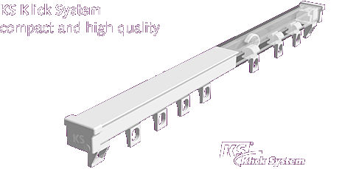
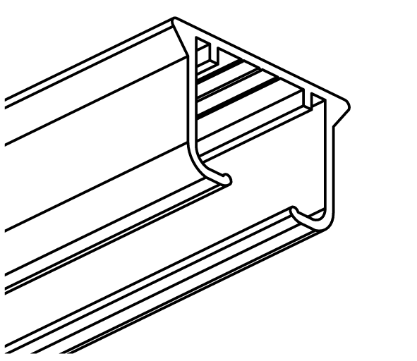 | 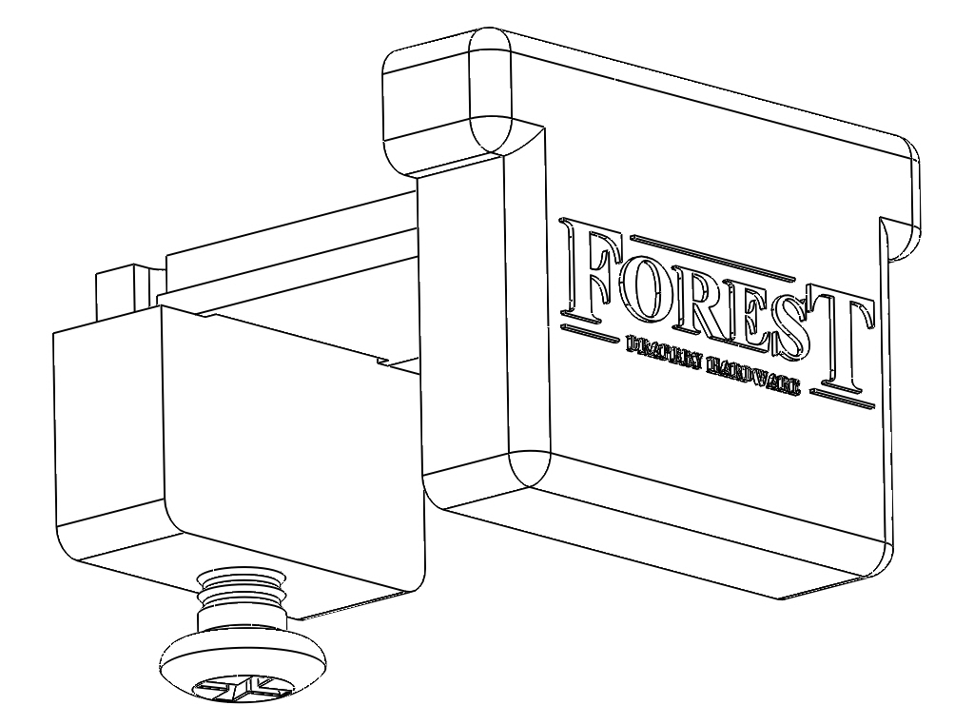 | 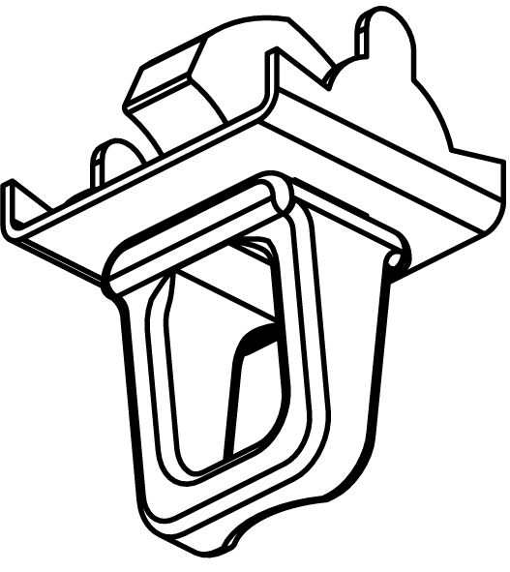
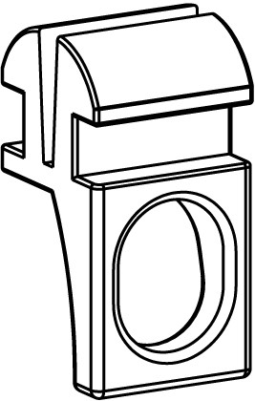 | 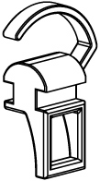 | 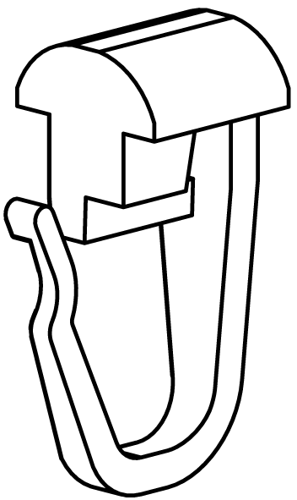
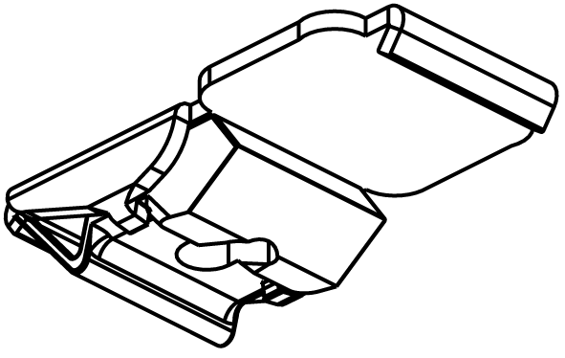 | 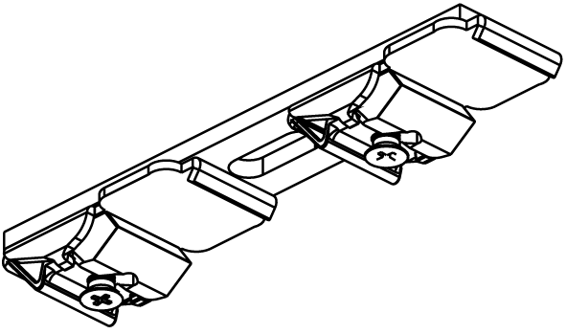 | 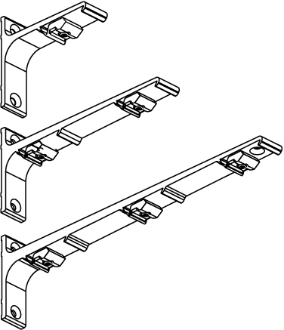
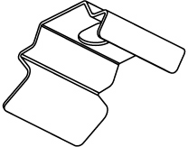 | 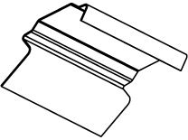 | 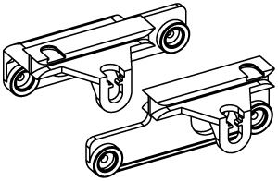

    - CKS System Series: Highly efficient medium duty cord traversing system with separate internal cord channels; preventing cord sag and eliminating cord tangle. Powder coated finish with track and carriers permanently lubricated for smooth operation.

      - Application: Cord drawn as follows:
        - Center close two way draw.
        - Off-center opening; two way draw.
        - One way draw left-to-right.
        - One way draw right-to-left.
        - Application as indicated on the Drawings.
        - Application as indicated on the Drapery Schedule.
      - Mounting: Suitable for fastening track to surface indicated and designed to support weight of track assemblies and drapery plus force applied to operate track. Provide steel brackets and intermediate supports every 60 to 90 cm, depending on weight of drape as required.
        - Number of Tracks:
          - Single.
          - Double.
          - Triple.
          - As indicated on the Drawings.
          - As indicated on the Drapery Schedule.
        - Wall with an adjustable or fixed projection.
        - Ceiling.
        - Recessed.
        - As indicated on the Drawings.
        - As indicated on the Drapery Schedule.
      - Drapery Style:
        - Pinch pleat with a nominal stackback of 6 inches (152 mm) per width.
        - Cubicle with a nominal stackback of 5 inches (127 mm) per width.
        - Accordiafold with a nominal stackback of 5 inches (127 mm) per width.
        - Ripplefold with a nominal stackback of 6 inches (152 mm) per width.
      - Track: Extruded aluminum KS Series, 6063 T5 alloy.
        - Track 3/4 inch (19 mm) wide by 1/2 inch (12.5 mm) high.
        - Lengths and Configurations: Provide track in the longest continuous lengths practical.
          - Straight sections as noted on the Drapery Schedule.
          - Straight sections as indicated on Drawings
          - Radius sections as noted on the Drapery Schedule.
          - Radius sections as indicated on Drawings.
        - Maximum Support Capability:
          - One way 60 LBS (27 kg).
          - Two way 120 LBS (54 kg), 4,5 kg/m¹.
        - Finish: Powder coated.
          - Black.
          - Brown.
          - Brass.
          - Beige.
          - Silver.
          - White.
      - Operation:
        - Cord: Braided nylon continuous loop with free end: Looped through wall mounted spring tensioned pulley.
        - Beaded Chain.
      - Carriers: UV protected for smooth and easy traversing:
        - Click carriers.
        - Carriers with snaps.
      - Master Carriers:
        - Overlap.
      - End Pulleys.

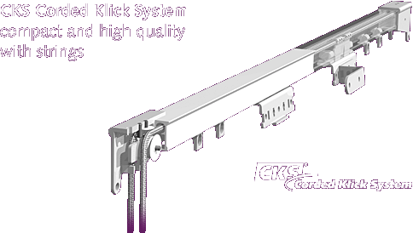
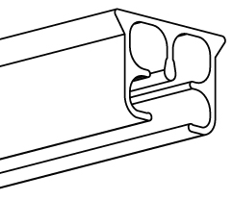 | 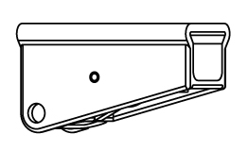 | 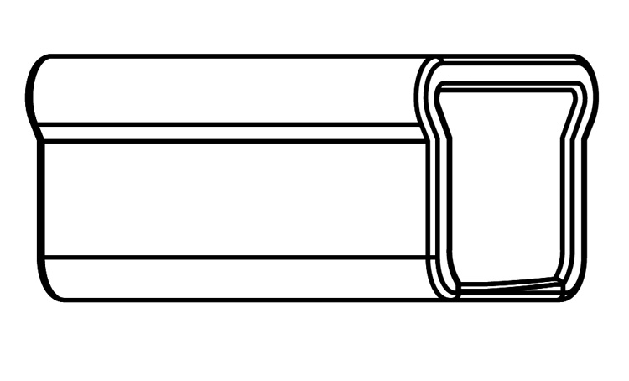
 |  | 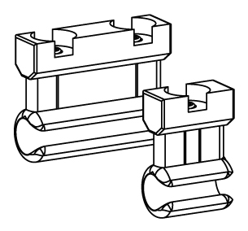
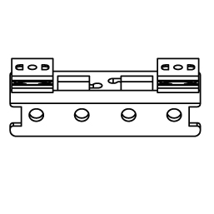 | 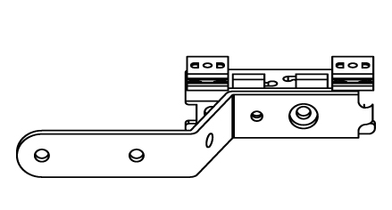 | 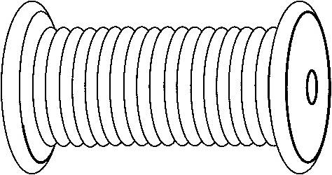


    - DS System Series: Highly efficient medium duty decorative fascia for hand drawn system for all types of medium weight draperies. Powder coated finish with track and carriers permanently lubricated for smooth operation.
      - Application: Hand drawn as follows:
        - Center close two way draw.
        - Off-center opening; two way draw.
        - One way draw left-to-right.
        - One way draw right-to-left.
        - Application as indicated on the Drawings.
        - Application as indicated on the Drapery Schedule.
      - Mounting: Suitable for fastening track to surface indicated and designed to support weight of track assemblies and drapery plus force applied to operate track. Provide steel brackets and intermediate supports every 60 to 90 cm, depending on weight of drape as required.
        - Number of Tracks:
          - Single.
          - As indicated on the Drawings.
          - As indicated on the Drapery Schedule.
        - Wall with an adjustable or fixed projection.
        - Ceiling.
        - Recessed.
        - Direct with channel protectors.
        - As indicated on the Drawings.
        - As indicated on the Drapery Schedule.
      - Drapery Style:
        - Pinch pleat with a nominal stackback of 6 inches (152 mm) per width.
        - Cubicle with a nominal stackback of 5 inches (127 mm) per width.
        - Accordiafold with a nominal stackback of 5 inches (127 mm) per width.
        - Ripplefold with a nominal stackback of 6 inches (152 mm) per width.
        - Shirring tape with a nominal stackback of 6 inches (152 mm) per width.
      - Track: Extruded aluminum DS Series, 6063 T5 alloy.
        - Track 15/16 inch (24 mm) wide by 7/16 inch (11 mm) high.
        - Lengths and Configurations: Provide track in the longest continuous lengths practical.
          - Straight sections as noted on the Drapery Schedule.
          - Straight sections as indicated on Drawings
          - Radius sections as noted on the Drapery Schedule.
          - Radius sections as indicated on Drawings.
        - Maximum Support Capability:
          - One way 60 LBS (27 kg).
          - Two way 120 LBS (54 kg), 4,5 kg/m¹.
        - Finish: Powder coated.
          - White.
          - Silver.
      - Operation:
        - Fibreglass baton white, ø 9.5 mm. b. Perspex baton transparent, ø 12 mm.
- 92 cm with baton. - 92 cm with baton.
- 122 cm with baton. - 122 cm with baton.
- 152 cm with baton. - 152 cm with baton
      - Carriers: UV protected for smooth and easy traversing:
        - Click carriers.
        - Click carriers with hooks.
        - Carriers with snaps.
      - Master Carriers:
        - Underlap.
        - Overlap.
      - End Stops.
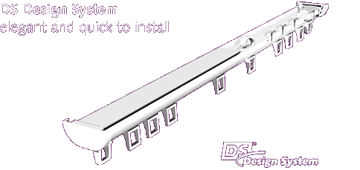
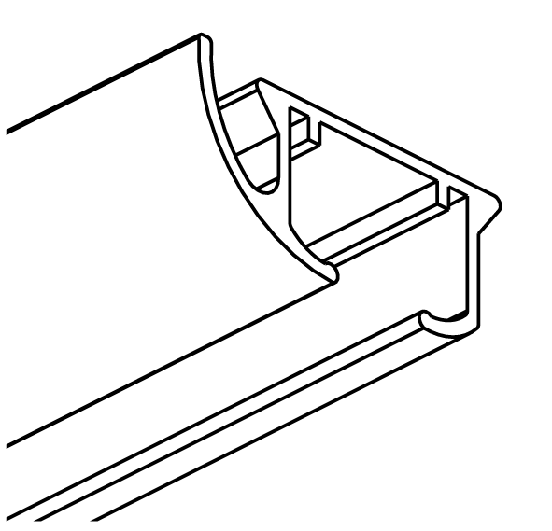 | 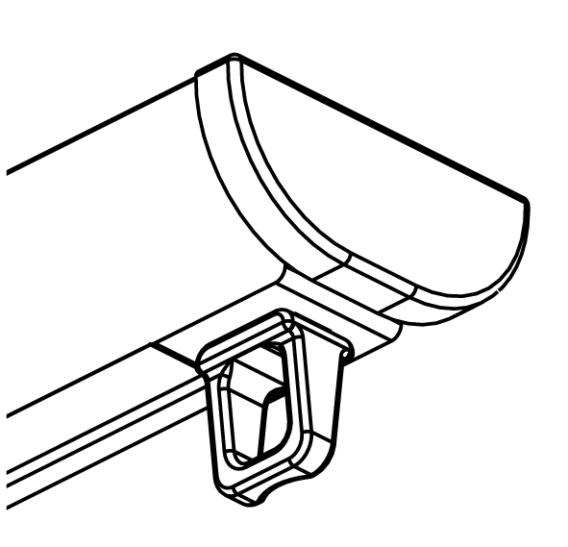
    - CS System Series: Highly efficient heavy duty hand drawn system for all types of draperies. Powder coated finish with track and carriers permanently lubricated for smooth operation.

      - Application: Hand drawn as follows:
        - Center close two way draw.
        - Off-center opening; two way draw.
        - One way draw left-to-right.
        - One way draw right-to-left.
        - Application as indicated on the Drawings.
        - Application as indicated on the Drapery Schedule.
      - Mounting: Suitable for fastening track to surface indicated and designed to support weight of track assemblies and drapery plus force applied to operate track. Provide steel brackets and intermediate supports every 60 to 90 cm, depending on weight of drape as required.
        - Number of Tracks:
          - Single.
          - Double.
          - Triple.
          - As indicated on the Drawings.
          - As indicated on the Drapery Schedule.
        - Wall with an adjustable or fixed projection.
        - Ceiling.
        - Recessed.
        - Direct with channel protectors.
        - As indicated on the Drawings.
        - As indicated on the Drapery Schedule.
      - Drapery Style:
        - Pinch pleat with a nominal stackback of 6 inches (152 mm) per width.
        - Cubicle with a nominal stackback of 5 inches (127 mm) per width.
        - Accordiafold with a nominal stackback of 5 inches (127 mm) per width.
        - Ripplefold with a nominal stackback of 6 inches (152 mm) per width.
      - Track: Extruded aluminum CS Series, 6063 T5 alloy.
        - Track 3/4 inch (19 mm) wide by 3/4 inch (19 mm) high.
        - Lengths and Configurations: Provide track in the longest continuous lengths practical.
          - Straight sections as noted on the Drapery Schedule.
          - Straight sections as indicated on Drawings
          - Radius sections as noted on the Drapery Schedule.
          - Radius sections as indicated on Drawings.
        - Maximum Support Capability:
          - One way 120 LBS (54 kg).
          - Two way 180 LBS (82 kg), 8 kg/m¹
        - Finish: Powder coated.
          - White.
          - Silver.
          - Brown.
      - Operation:
        - Fibreglass baton white, ø 9.5 mm. b. Perspex baton transparent, ø 12 mm.
- 92 cm with baton. - 92 cm with baton.
- 122 cm with baton. - 122 cm with baton.
- 152 cm with baton. - 152 cm with baton
        - Carriers: UV protected for smooth and easy traversing:
        - Click carriers.
        - Click carriers with hooks.
        - Carriers with snaps.
      - Master Carriers:
        - Underlap.
        - Overlap.
      - End Stops.
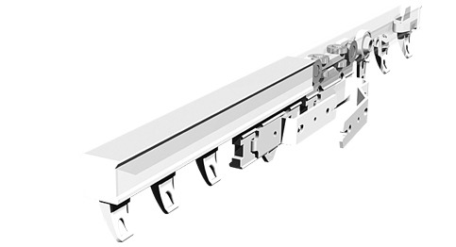
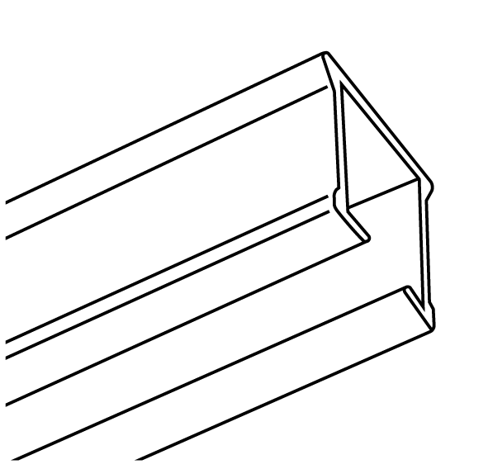 | 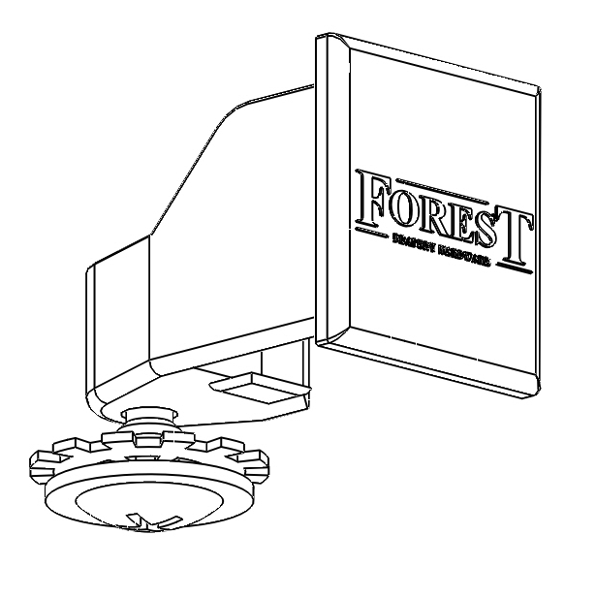 | 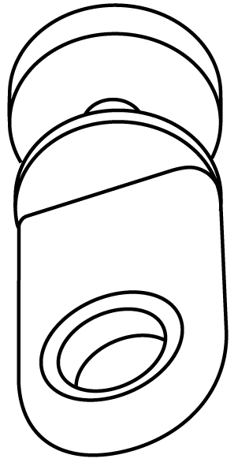
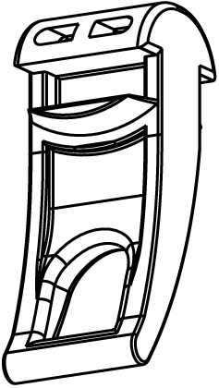 | 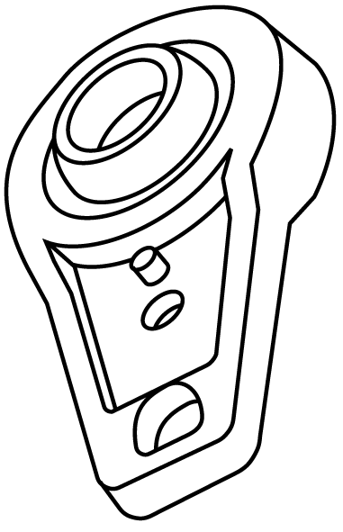 | 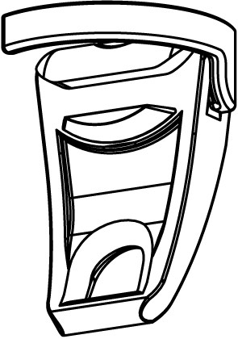
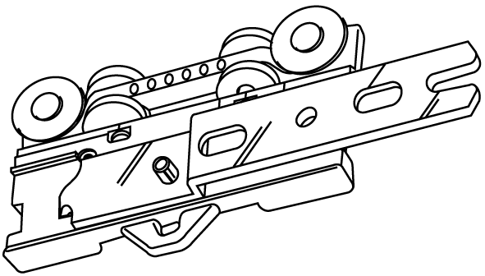 | 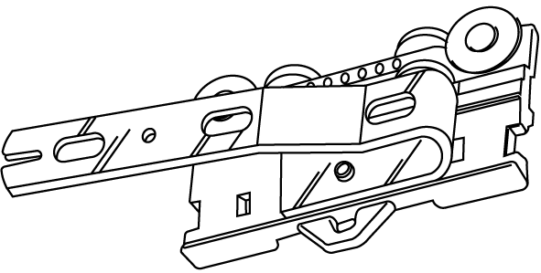 | 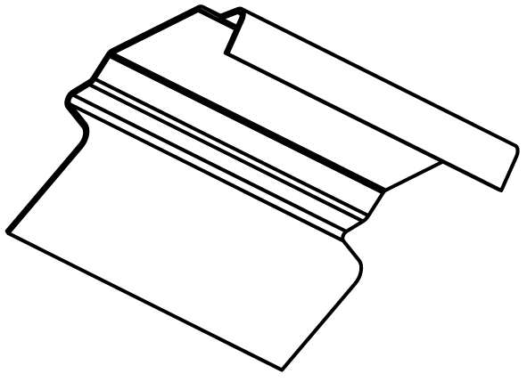

    - CS Lip System Series: Highly efficient heavy duty hand drawn system for all types of draperies. Powder coated finish with track and carriers permanently lubricated for smooth operation.
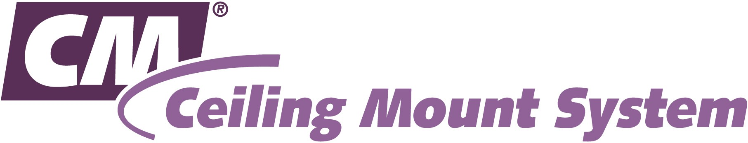
      - Application: Hand drawn as follows:
        - Center close two way draw.
        - Off-center opening; two way draw.
        - One way draw left-to-right.
        - One way draw right-to-left.
        - Application as indicated on the Drawings.
        - Application as indicated on the Drapery Schedule.
      - Mounting: Direct ceiling mount designed to support weight of track assemblies and drapery plus force applied to operate track.
        - Number of Tracks:
          - Single.
          - As indicated on the Drawings.
          - As indicated on the Drapery Schedule.
        - Ceiling.
        - As indicated on the Drawings.
        - As indicated on the Drapery Schedule.
      - Drapery Style:
        - Pinch pleat with a nominal stackback of 6 inches (152 mm) per width.
        - Cubicle with a nominal stackback of 5 inches (127 mm) per width.
        - Accordiafold with a nominal stackback of 5 inches (127 mm) per width.
        - Ripplefold with a nominal stackback of 6 inches (152 mm) per width.
      - Track: Extruded aluminum CS Series, 6063 T5 alloy.
        - Track 1-3/8 inch (29 mm) top by 3/4 inch (19 mm) bottom.
        - Lengths and Configurations: Provide track in the longest continuous lengths practical.
          - Straight sections as noted on the Drapery Schedule.
          - Straight sections as indicated on Drawings
        - Maximum Support Capability:
          - One way 120 LBS (54 kg).
          - Two way 240 LBS (109 kg), 8 kg/m¹.
        - Finish: Powder coated.
          - White.
      - Operation:
        - Fibreglass baton white, ø 9.5 mm. b. Perspex baton transparent, ø 12 mm.
- 92 cm with baton. - 92 cm with baton.
- 122 cm with baton. - 122 cm with baton.
- 152 cm with baton. - 152 cm with baton
        - Carriers: UV protected for smooth and easy traversing:
        - Click carriers.
        - Click carriers with hooks.
        - Carriers with snaps.
      - Master Carriers:
        - Underlap.
        - Overlap.
      - End Stops.

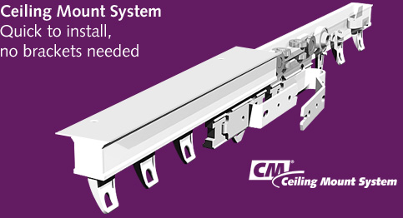
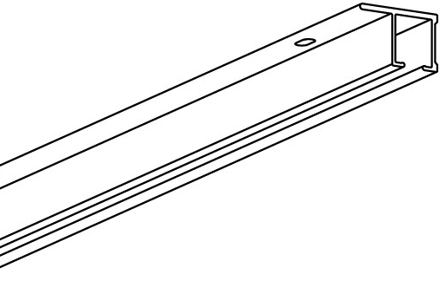 | 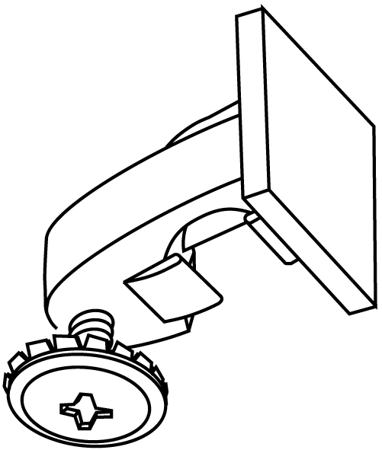
    - CCS System Series: Highly efficient heavy duty cord traverse system, with separate internal cord channels; preventing cord sag and eliminating cord tangle for all types of draperies. Powder coated finish with track and carriers permanently lubricated for smooth operation.

      - Application: Cord drawn as follows:
        - Center close two way draw.
        - Off-center opening; two way draw.
        - One way draw left-to-right.
        - One way draw right-to-left.
        - Application as indicated on the Drawings.
        - Application as indicated on the Drapery Schedule.
      - Mounting: Suitable for fastening track to surface indicated and designed to support weight of track assemblies and drapery plus force applied to operate track. Provide steel brackets and intermediate supports every 60 to 90 cm, depending on weight of drape as required.
        - Number of Tracks:
          - Single.
          - Double.
          - Triple.
          - As indicated on the Drawings.
          - As indicated on the Drapery Schedule.
        - Wall with an adjustable or fixed projection.
        - Ceiling.
        - Recessed.
        - As indicated on the Drawings.
        - As indicated on the Drapery Schedule.
      - Drapery Style:
        - Pinch pleat with a nominal stackback of 6 inches (152 mm) per width.
        - Accordiafold with a nominal stackback of 5 inches (127 mm) per width.
        - Ripplefold with a nominal stackback of 6 inches (152 mm) per width.
      - Track: Extruded aluminum CS Series, 6063 T5 alloy.
        - Track 3/4 inch (19 mm) wide by 3/4 inch (19 mm) high.
        - Lengths and Configurations: Provide track in the longest continuous lengths practical.
          - Straight sections as noted on the Drapery Schedule.
          - Straight sections as indicated on Drawings
          - Radius sections as noted on the Drapery Schedule.
          - Radius sections as indicated on Drawings.
        - Maximum Support Capability:
          - One way 80 LBS (36 kg).
          - Two way 120 LBS (54 kg), 8 kg/m¹
        - Finish: Powder coated.
          - Brown.
          - Silver.
          - White.
      - Operation:
        - Cord: Braided nylon continuous loop with free end: Looped through wall mounted spring tensioned pulley.
        - Beaded Chain.
      - Carriers: UV protected for smooth and easy traversing:
        - Click carriers.
        - Carriers with snaps.
      - Master Carriers:
        - Overlap.
      - End Pulleys.

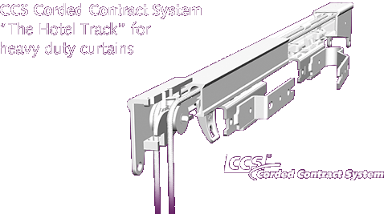
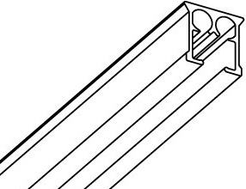 | 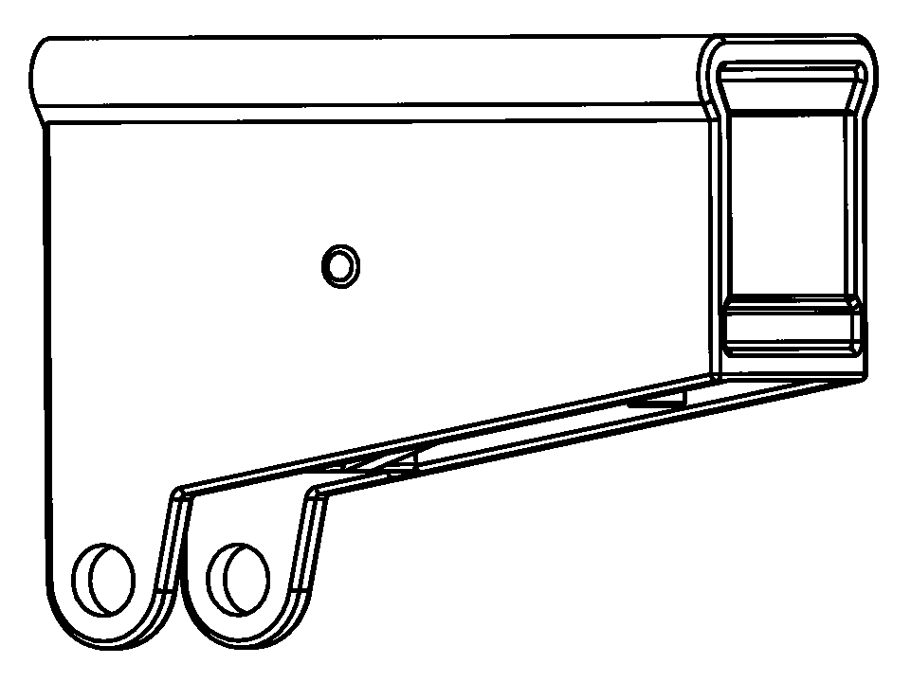 | 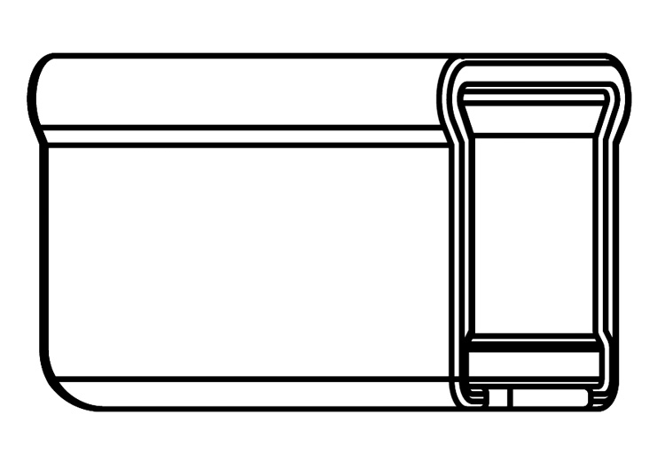
 | 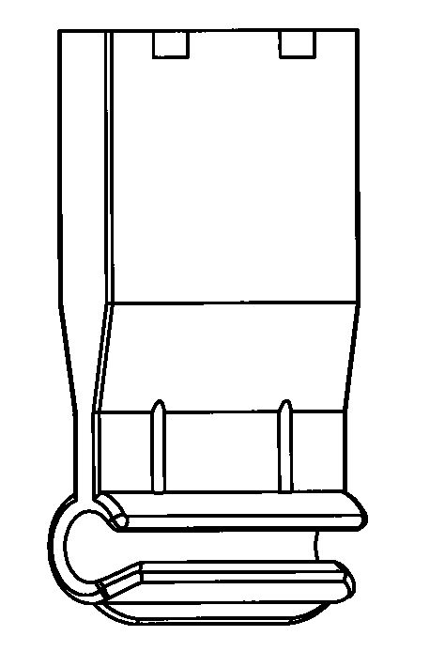
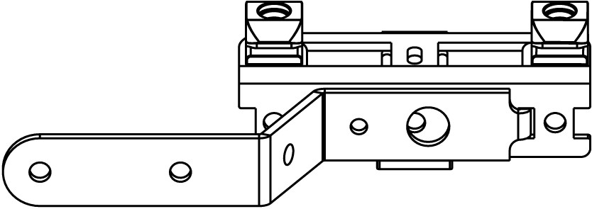 |  | 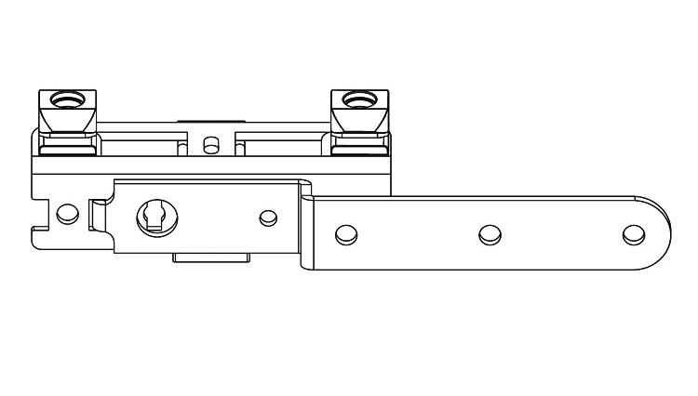

    - MTS System Series: Highly efficient heavy duty hand drawn system for privacy curtains. Powder coated finish with track and carriers permanently lubricated for smooth operation.

      - Application: Hand drawn as follows:
        - Center close two way draw.
        - Off-center opening; two way draw.
        - One way draw left-to-right.
        - One way draw right-to-left.
        - Application as indicated on the Drawings.
        - Application as indicated on the Drapery Schedule.
      - Mounting: Suitable for fastening track to surface indicated and designed to support weight of track assemblies and drapery plus force applied to operate track. Provide steel brackets and intermediate supports every 90 to 150 cm, depending on weight of drape as required.
        - Number of Tracks:
          - Single.
          - As indicated on the Drawings.
          - As indicated on the Drapery Schedule.
        - Wall with an adjustable or fixed projection.
        - Ceiling suspended poles up to 150cm in length, or straight against ceiling.
        - Recessed.
        - As indicated on the Drawings.
        - As indicated on the Drapery Schedule.
      - Drapery Style:
        - Cubicle with a nominal stackback of 5 inches (127 mm) per width.
        - Pinch pleat with a nominal stackback of 6 inches (152 mm) per width.
        - Accordiafold with a nominal stackback of 5 inches (127 mm) per width.
        - Ripplefold with a nominal stackback of 6 inches (152 mm) per width.
      - Track: Extruded aluminum MTS Series, 6063 T5 alloy, Chromated, Powder Coated.
        - Track 19,6 mm wide by 30 mm high.
        - Track available in 580 cm and 700 cm lengths.
        - Lengths and Configurations: Provide track in the longest continuous lengths practical.
          - Straight sections as noted on the Drapery Schedule.
          - Straight sections as indicated on Drawings
          - Radius sections as noted on the Drapery Schedule.
          - Radius sections as indicated on Drawings.
        - Maximum Support Capability:
          - 10 kgs per running meter of track
        - Finish: Powder coated and anti-friction treated with factory applied dry lubricant:
          - White.
        - Bendable in continuous radius or at 90 degrees with a 20cm radius.
      - Operation:
        - By hand
        - Fibreglass baton white, ø 9.5 mm. b. Perspex baton transparent, ø 12 mm.
- 92 cm with baton. - 92 cm with baton.
- 122 cm with baton. - 122 cm with baton.
- 152 cm with baton. - 152 cm with baton
        - Carriers: UV protected for smooth and easy traversing:
        - Rotating carriers with hooks.
        - Click carriers.
        - Carriers with snaps.
      - Dust strip:
        - Synthetic rubber dust strip to cover the top channel of the MTS tracks, to prevent dust and bacteria from collecting.
      - Curtain securing:
        - By wall fixed tieback, to keep the curtains neatly stacked when open.

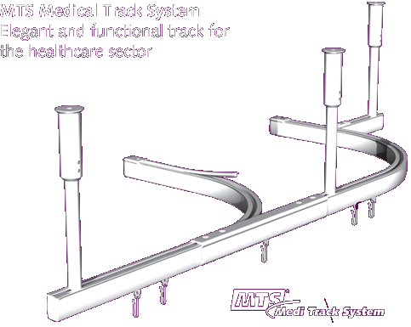
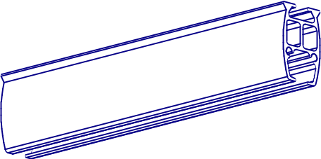 | 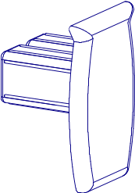 | 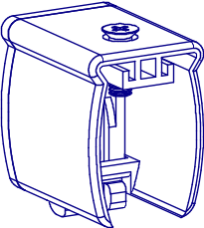
 | 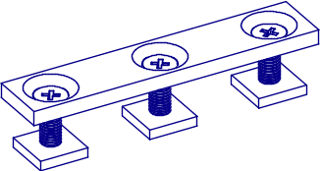 | 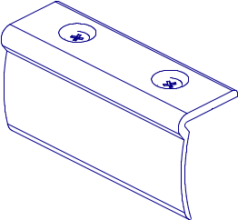
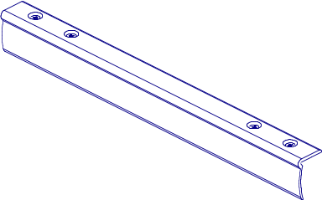 | 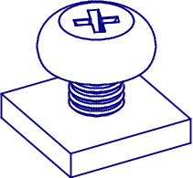 | 
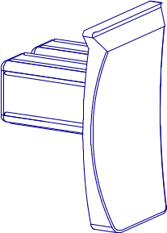 | 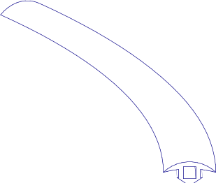 | 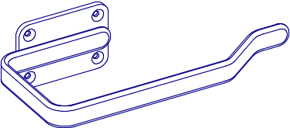
    - Roman Blind System BS series: Extruded aluminum headrail, powder coated, integrated hook and Velcro tape. Patented pull up drums for guaranteed smooth and level operation, quick and easy field or shop assembly.

      - Application: Heavy duty headrail, all drums self contained inside headrail
        - Multiple drums available based on length.
        - Up to 19 foot (5.8 m) lengths available
      - Mounting: Suitable for fastening headrail to surface indicated and designed to support weight of roman shade assemblies plus force applied to operate track. Provide steel brackets and intermediate supports every 60 to 90 cm, depending on weight of shade as required.
        - Number of Headrails:
          - Single.
          - As indicated on the Drawings.
          - As indicated on the Drapery Schedule.
        - Wall with a swivel or spring action mounting bracket.
        - Ceiling with a swivel or spring action mounting bracket.
        - As indicated on the Drawings.
        - As indicated on the Drapery Schedule.
      - Headrail: Extruded aluminum BS Series, 6063 T5 alloy.
        - Size: 1-3/8 inches (35 mm) wide by 1-1/2 inches (38 mm) high.
        - Lengths and Configurations: Provide track in the longest continuous lengths practical.
          - Straight sections as noted on the Drapery Schedule.
          - Straight sections as indicated on Drawings.
        - Maximum Support Capability:
          - 1:4 self braking gear control units maximum weight 7 kg
          - 1:1 self braking gear control units maximum weight 7 kg
        - Finish: Powder coated.
          - White.
      - Operation:
        - Cord roll support with cord: adjustable after installation. Contains a drop length of 12 feet (3.6 m) standard, can be shortened to actual length needed.
        - Endless Chain 6 mm pitch or 12 mm pitch, white or transparent; drop:
          - 75 cm.
          - 100 cm.
          - 125 cm
          - 150 cm.
          - 175 cm.
          - 200 cm.
          - 250 cm.
          - 300 cm
          - Drop as noted on the Drapery Schedule.
          - Drop as indicated on Drawings.
      - Valance kits available.
      - Spines.
      - Shade Levelers.

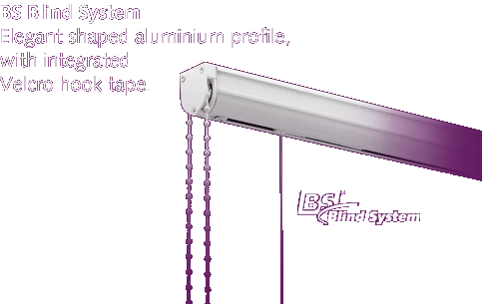
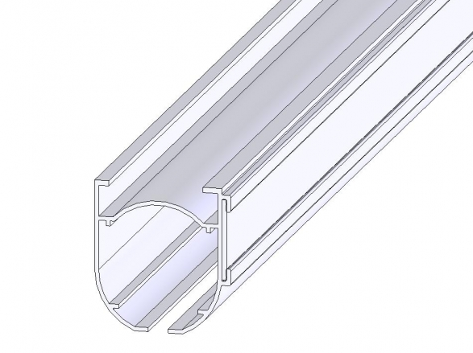 | 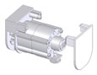 | 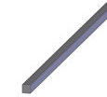
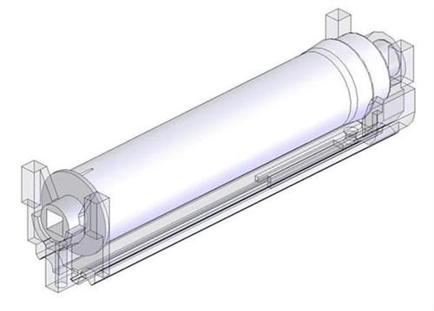 | 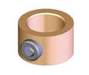 | 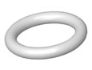
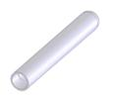 | 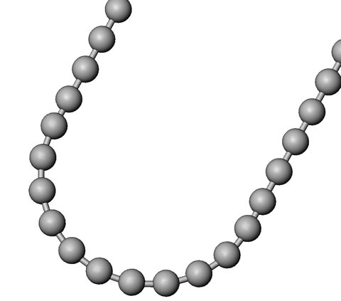 | 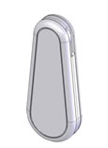
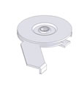 | 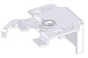 | 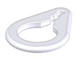
  - MOTOR OPERATED TRACK AND ACCESSORIES


    - FMS System using FMS Series: Heavy duty, belt driven motorized track with separate internal belt channels; preventing belt sag and eliminating belt tangle. Quiet operation.
      - Application: Belt drawn as follows:
        - Center opening; two way draw.
        - Off-center opening; two way draw
        - One way draw left-to-right.
        - One way draw right-to-left.
      - Operation: Motor operated.
        - Power supply, 220 VAC.
        - Motor type, 30W (0,8 Nm), 45W (1,2 Nm) or 60W (1,6 Nm).
        - Remote: 15 channel Forest Multi Remote with integrated timer.
        - Manual wall switch.
        - Building automation control system.
      - Mounting: Suitable for fastening track to surface indicated and designed to support weight of track assemblies and drapery plus force applied to operate track. Provide steel brackets and intermediate supports every 60 to 90 cm, depending on weight of drape as required. Motor can be placed downwards and upwards.
        - Number of Tracks:
          - Single.
          - Double.
          - Triple.
          - As indicated on the Drawings.
          - As indicated on the Drapery Schedule.
        - Wall with an adjustable or fixed projection.
        - Ceiling.
        - Recessed.
        - As indicated on the Drawings.
        - As indicated on the Drapery Schedule.
      - Drapery Style:
        - Pinch pleat with a nominal stackback of 7 inches (179 mm) per width.
        - Accordiafold with a nominal stackback of 5 inches (127 mm) per width.
        - Ripplefold with a nominal stackback of 6 inches (152 mm) per width.
      - Track: Extruded aluminum FMS Series, 6063 T5 alloy.
        - Track 3/4 inch (20 mm) wide by 3/4 inch (20 mm) high.
        - Lengths and Configurations: Provide track in the longest continuous lengths practical.
          - Straight sections as noted on the Drapery Schedule.
          - Straight sections as indicated on Drawings
          - Radius sections as noted on the Drapery Schedule.
          - Radius sections as indicated on Drawings.
        - Maximum Support Capability:
          - One way 65 kg, or 10 kg /m¹.
          - Two way 65 kg, or 10 kg /m¹.
        - Finish: Powder coated.
          - White.
      - Carriers: UV protected for smooth and easy traversing
        - Click carriers
        - Carriers with snaps
      - Master Carriers
        - Overlap
        - End Pulleys.

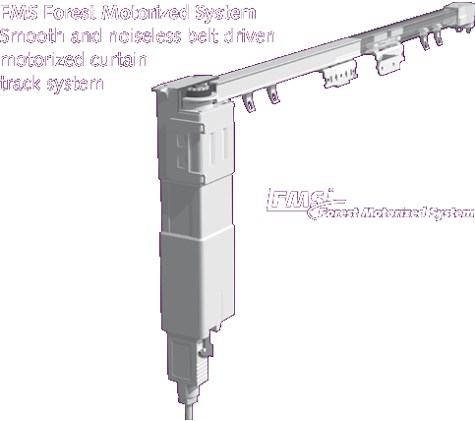
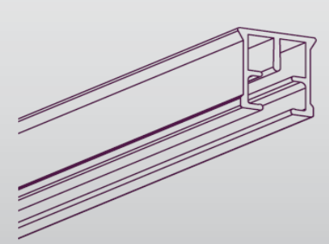 | 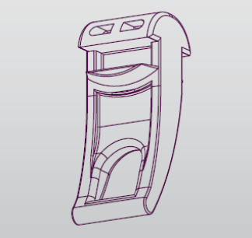 | 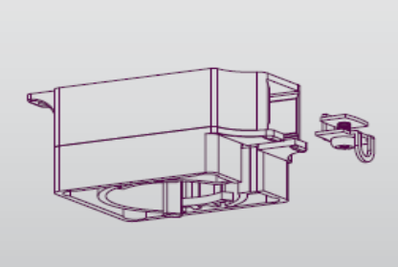
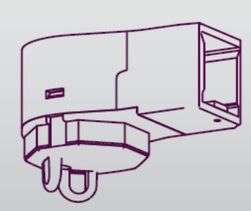 | 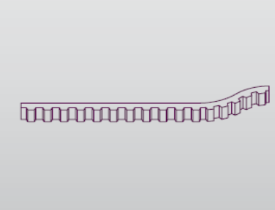 | 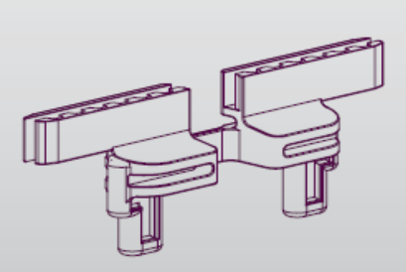
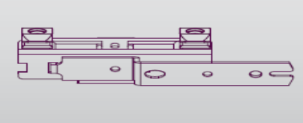 | 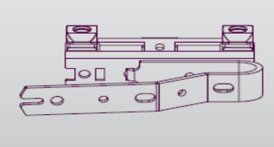 | 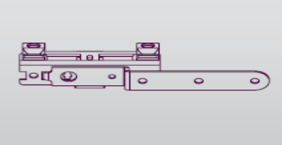
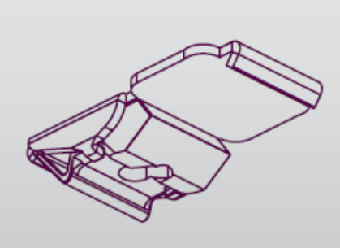 | 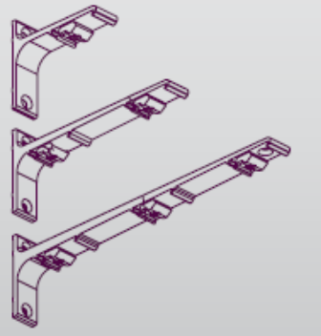 | 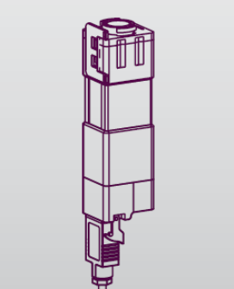
    - Forest Shuttle System using FMS Track Series: Heavy duty, belt driven motorized track with separate internal belt channels; preventing belt sag and eliminating belt tangle. Operates by simply touching drapes or by radio frequency remote control. Built in switch off when draperies open or closed. Clutch system inside motor so drapes can be operated in case of power failure. Automatic adjustment of motor. Slow start – slow stop, auto-feature. Suitable for all types of draperies from sheers to velvets. Easy installation without electrical engineer. Compatible with home automation, quiet operation.

      - Application: Belt drawn as follows:
        - Center opening; two way draw.
        - Off-center opening; two way draw
        - One way draw left-to-right.
        - One way draw right-to-left.
      - Operation: Motor operated.
        - Power supply: 240 – 110 VAC power adaptor, 24V DC output.
        - Motor type, 24V DC.
        - Remote: Forest Multi remote, Infrared or Radio Frequency Z-wave remote.
        - Dry contact port for building automation system integration.
        - Wired wall switch on dry contact port.
        - Touch impulse activated switch.
        - Maximum Torque: 1,8 Nm
      - Mounting: Suitable for fastening track to surface indicated and designed to support weight of track assemblies and drapery plus force applied to operate track. Provide brackets and intermediate supports every 50 to 90 cm, depending on weight of drape as required. Motor can be placed downwards and upwards.
        - Number of Tracks:
          - Single.
          - Double.
          - Triple.
          - As indicated on the Drawings.
          - As indicated on the Drapery Schedule.
        - Wall with an adjustable or fixed projection.
        - Ceiling.
        - Recessed.
        - As indicated on the Drawings.
        - As indicated on the Drapery Schedule.
      - Drapery Style:
        - Pinch pleat with a nominal stackback of 7 inches per width.
        - Accordiafold with a nominal stackback of 5 inches (127 mm) per width.
        - Ripplefold with a nominal stackback of 6 inches (152 mm) per width.
      - Track: Extruded aluminum Series, 6063 T5 alloy.
        - Track 3/4 inch (20 mm) wide by 3/4 inch (20 mm) high.
        - Lengths and Configurations: Provide track in the longest continuous lengths.
          - Straight sections as noted on the Drapery Schedule.
          - Straight sections as indicated on Drawings
          - Radius sections as noted on the Drapery Schedule.
          - Radius sections as indicated on Drawings.
          - 20 cm radius available
          - Continuous curving available from factory with drawn template
          - Splicing not recommended, 20 foot lengths maximum for 1 motor.
        - Maximum Support Capability:
          - One way 70 kg, or 10 kg /m¹.
          - Two way 70 kg, or 10 kg /m¹.
        - Finish: White powder coated finish only
      - Carriers: UV protected for smooth and easy traversing
        - Click carriers
        - Carriers with snaps
      - Master Carriers
        - Overlap
        - Underlap.
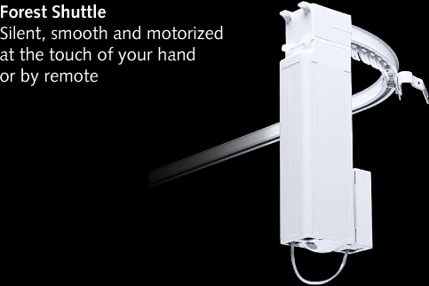
 |  | 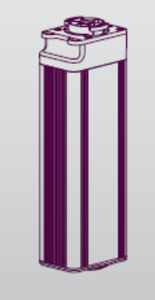 | 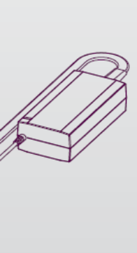
    - Blind Contract System Series: Heavy duty motorized roman blind system. Integrated velcro tape. Patented cord drums for guaranteed smooth and level operation, quick and easy field or shop assembly.
      - Application: Heavy duty headrail, all drums self contained inside headrail
        - Multiple drums available based on length.
        - Up to 19 foot (5.8 m) lengths available.
        - Up to 5.5 m height operation available.
      - Mounting: Suitable for fastening headrail to surface indicated and designed to support weight of roman shade assemblies plus force applied to operate track. Provide aluminium wall brackets or steel ceiling brackets; intermediate supports every 60 to 90 cm, depending on weight of shade as required.
        - Number of Headrails:
          - Single.
          - As indicated on the Drawings.
          - As indicated on the Drapery Schedule.
        - Wall with a spring action mounting bracket.
        - Ceiling with a swivel or spring action mounting bracket.
        - As indicated on the Drawings.
        - As indicated on the Drapery Schedule.
      - Headrail: Extruded aluminum BCS Series, 6063 T5 alloy, powder coated white finish.
        - Size: 62 mm wide by 73 mm high.
        - Lengths and Configurations: Provide track in the longest continuous lengths practical.
          - Straight sections as noted on the Drapery Schedule.
          - Straight sections as indicated on Drawings.
      - Operation: Motor operated:
        - Power supply, 220 VAC.
        - Motor types: 3Nm/26rpm; 6Nm/26rpm; 13Nm/14rpm
        - Available as standard motor and as motor with integrated receiver
        - Electronic settings of top and bottom end limits.
        - Remote: Forest Multi Remote 15-channels with integrated timer
        - Manual wall switch.
        - Compatible with home automation, quiet operation.

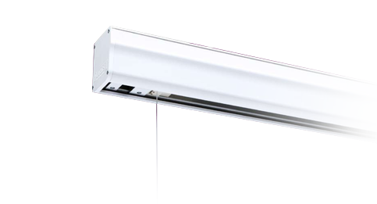
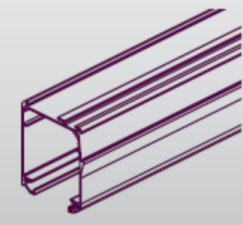 | 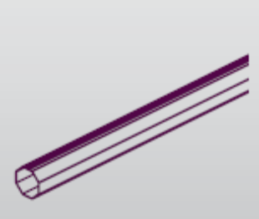 | 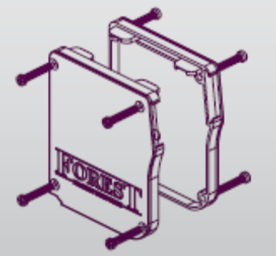
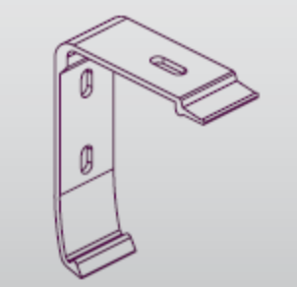 | 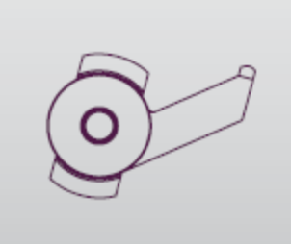 | 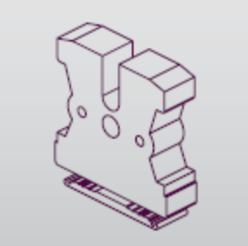
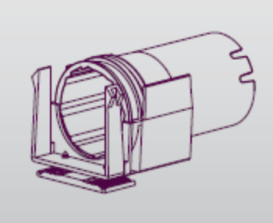 | 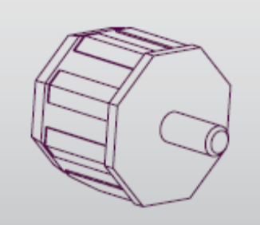 | 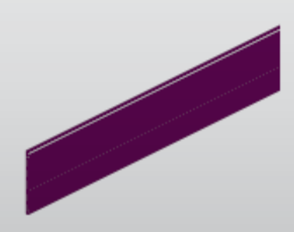
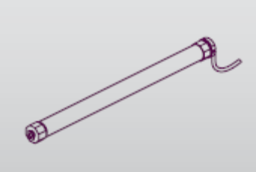 | 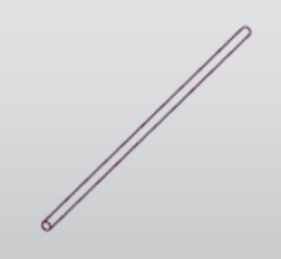 | 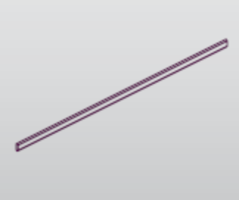
  - INSTALLATION AND HANGING ACCESSORIES
    - Universal Brackets.Forest Drapery Hardware has developed universal brackets for the following systems: KS, DS, CS, CKS, CCS, FMS, SHUTTLE. The below mentioned brackets have been especially developed to provide the greatest level of stability and strength.


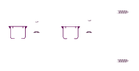
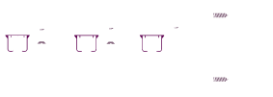

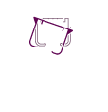
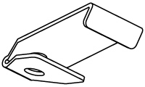
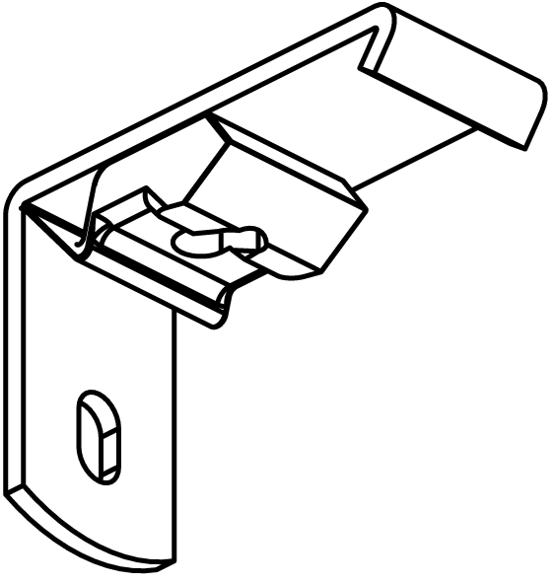 | 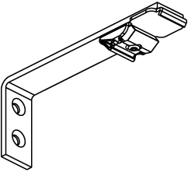 | 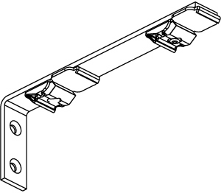
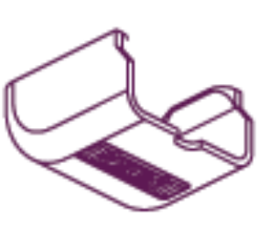 | 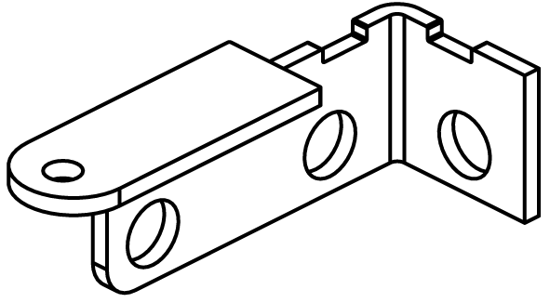 | 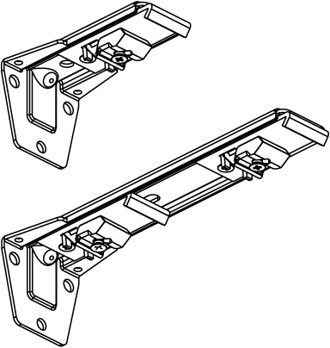


    - Forest Easyfold System. This system is an additional feature for the existing drapery hardware of Forest Group. It can be installed onto the Forest Group drapery hardware, giving a special folding design to a curtain.

REGULAR | Distance | No. Snaps | Length Mtr | Covers track
RDS 80% | 6,03 | 1000 | 60,30 | 60,30
RDS 100% | 5,40 | 1000 | 54,00 | 54,00
EASY SNAP | Distance | No. Snaps | Length Mtr | Covers track
RDS 80% | 6,03 | 500 | 30,15 | 30,15
RDS 100% | 5,40 | 500 | 27,00 | 27,00
RDS TAPE | Distance | No. Snaps | Length Mtr | Length CM
Normal white | 10,75 | 850 | 91,44 | 9144
Heavy duty white | 10,75 | 850 | 91,44 | 9144
Transparant | 10,75 | 850 | 91,44 | 9144
Normal black | 10,75 | 850 | 91,44 | 9144
HD White XL | 15,75 | 580 | 91,44 | 9144
Transparant XL | 15,75 | 580 | 91,44 | 9144
REGULAR | RDS 80% | Curtain / FES | Curtain | Carriers | Tape
Rail Length CM | Carriers | Tape CM | Stacking * | No. Of Rolls | No. Of Rolls
300 | 50 | 540 | 75 | 0,05 | 0,06
400 | 66 | 720 | 100 | 0,07 | 0,08
500 | 83 | 900 | 125 | 0,08 | 0,10
600 | 100 | 1080 | 150 | 0,10 | 0,12
700 | 116 | 1260 | 175 | 0,12 | 0,14
REGULAR | RDS 100% | Curtain / FES | Curtain | Carriers | Tape
Rail Length CM | Carriers | Tape CM | Stacking * | No. Of Rolls | No. Of Rolls
300 | 56 | 600 | 79,50 | 0,06 | 0,07
400 | 74 | 800 | 106,00 | 0,07 | 0,09
500 | 93 | 1000 | 132,50 | 0,09 | 0,11
600 | 111 | 1200 | 159,00 | 0,11 | 0,13
700 | 130 | 1400 | 185,50 | 0,13 | 0,15
EASY SNAP | RDS 80% | Curtain / FES | Curtain | Carriers | Tape
Rail Length CM | Carriers | Tape CM | Stacking * | No. Of Rolls | No. Of Rolls
300 | 50 | 540 | 79,50 | 0,10 | 0,06
400 | 66 | 720 | 106,00 | 0,13 | 0,08
500 | 83 | 900 | 132,50 | 0,17 | 0,10
600 | 100 | 1080 | 159,00 | 0,20 | 0,12
700 | 116 | 1260 | 185,50 | 0,23 | 0,14
EASY SNAP | RDS 100% | Curtain / FES | Curtain | Carriers | Tape
Rail Length CM | Carriers | Tape CM | Stacking * | No. Of Rolls | No. Of Rolls
300 | 56 | 600 | 85,50 | 0,11 | 0,07
400 | 74 | 800 | 114,00 | 0,15 | 0,09
500 | 93 | 1000 | 142,50 | 0,19 | 0,11
600 | 111 | 1200 | 171,00 | 0,22 | 0,13
700 | 130 | 1400 | 199,50 | 0,26 | 0,15
* Curtain Stacking: Based on manual tracks KS, DS or CS; without master carrier; one-way or middle closing.

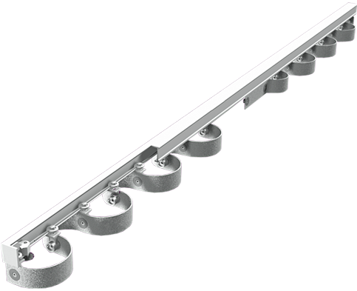
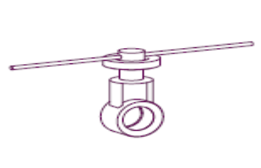 | 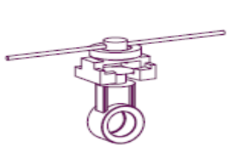 | 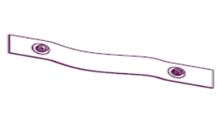
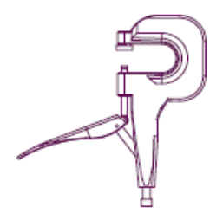  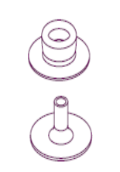 | 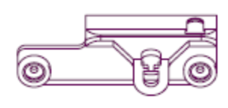  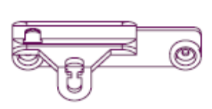 | 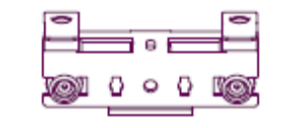  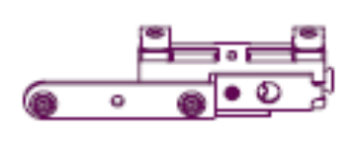
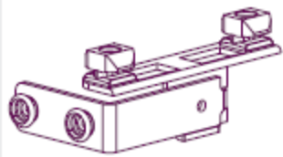  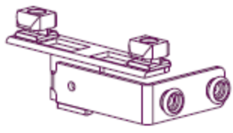 | 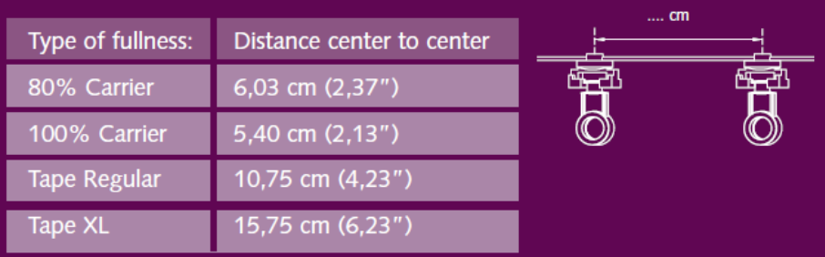
PART 3: EXECUTION
3.1 EXAMINATION
    - Do not begin installation until substrates have been properly prepared.
    - Verify concealed blocking and anchors are in correct position.
    - If substrate preparation is the responsibility of another installer, notify Architect of unsatisfactory preparation before proceeding.
3.2 PREPARATION
    - Clean surfaces thoroughly prior to installation.
    - Prepare surfaces using the methods recommended by the manufacturer for achieving the best result for the substrate under the project conditions.
3.3 INSTALLATION
    - Install in accordance with manufacturer's instructions.
    - Mount equipment support brackets on solid backing. Where mounting location does not align with solid backing, use expanding anchors for each screw hole location.
    - Use the necessary screws, plugs, toggle bolts, or anchors necessary to produce a heavy duty installation permitting no loosening of brackets, tracks or other operating parts when subject to extensive use.
    - Adjust drapery hardware for smooth operation.
3.4 PROTECTION
    - Protect installed products until completion of project.
3.5 SCHEDULE
    - Single Track System: At exterior windows except living rooms; extending track 14 inches (350 mm) beyond both sides of interior window trim.
    - Double Track System: At living rooms; extending track 32 inches (800 mm) on north side of window opening, motorized with switch located next to room light switch.

END OF SECTION

